
RAMAIAH
INSTITUTE OF TECHNOLOGY
USN | 1 | M | S

(Autonomous Institute, Affiliated to VTU)
(Approved by AICTE, New Delhi & Govt. of Karnataka) Accredited by NBA & NAAC with ‘A’ Grade

SEMESTER END EXAMINATIONS – JANUARY 2018

Course & Branch | : | B.E. : Common to all Branches | Semester | : | I
Subject | : | Engineering Mathematics | Max. Marks | : | 100
Subject Code | : | MAT101 | Duration | : | 3 Hrs

Instructions to the Candidates:
- Answer one full question from each unit.

 |  | UNIT- I
1. | a) | Write the formula to find angle between the radius vector and the tangent to a polar curve and explain the terms involved. | CO1 | (02)
 | b) | Show that the tangent to the cardioid 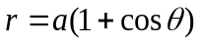 at 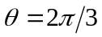 is perpendicular to the initial line. | CO1 | (04)
 | c) | If 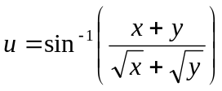 then prove that  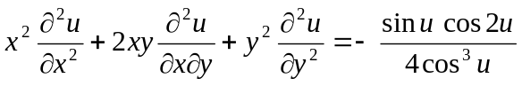. | CO1 | (07)
 | d) | If 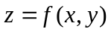where 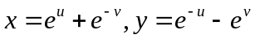 then show that 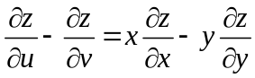 | CO1 | (07)
2. | a) | Define homogeneous function of two and three variables. | CO1 | (02)
 | b) | Find the pedal equation for the curve r^{n}=a^{n} cosnθ. | CO1 | (04)
 | c) | Find the angle of intersection of the following pair of curves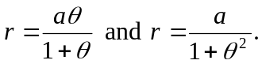 | CO1 | (07)
 | d) | If 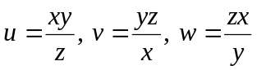 then find the Jacobian 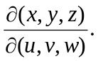 | CO1 | (07)
 |  | UNIT- II
3. | a) | Write the expression to find the surface area of solid of revolution for a cartesian curve when rotated about and axes. | CO2 | (02)
 | b) | Using reduction formula, evaluate 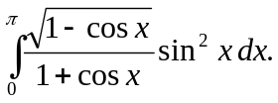 | CO2 | (04)
 | c) | Determine the arc length of the cardioid 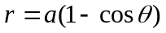lying outside the circle 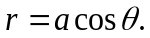 | CO2 | (07)
 | d) | Trace the curve 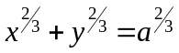. | CO2 | (07)
4. | a) | Identify the double point for the curve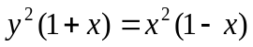. | CO2 | (02)
 | b) | Prove that the area of loop of the curve 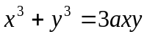 is 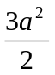. | CO2 | (04)
 | c) | By differentiation under the integral sign, evaluate 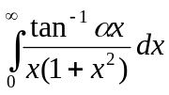.  Hence find 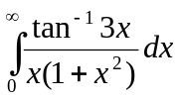. | CO2 | (07)
 | d) | Find the volume of revolution generated by the curve 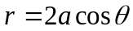 about the initial line. | CO2 | (07)
 |  | UNIT- III
5. | a) | With the help of a neat diagram, mark the region of integration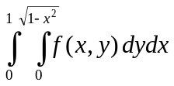. | CO3 | (02)
 | b) | Evaluate 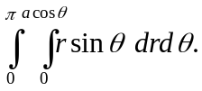 | CO3 | (04)
 | c) | Let  be the region in the first quadrant bounded by the curves 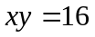, 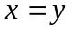, 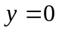 and 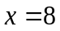. Sketch the region of integration and evaluate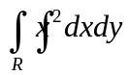. | CO3 | (07)
 | d) | Evaluate 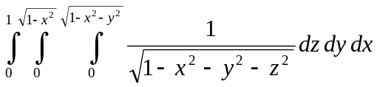 by changing to spherical coordinates. | CO3 | (07)
6. | a) | Write the relation between cartesian and cylindrical polar coordinates. | CO3 | (02)
 | b) | Evaluate by changing into polar coordinates 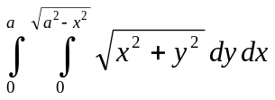. | CO3 | (04)
 | c) | Find the volume of the tetrahedron bounded by the planes 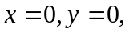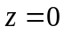 and 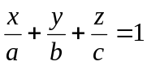 using triple integration. | CO3 | (07)
 | d) | Evaluate by changing the order of integration 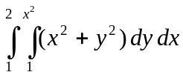 . | CO3 | (07)
 |  | UNIT- IV
7. | a) | Explain geometrical meaning of gradient of a scalar field. | CO4 | (02)
 | b) | In a temperature field ,heat flows in the direction of maximum decrease of temperature T. Find this direction at (2,1) when 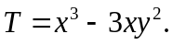 | CO4 | (04)
 | c) | Show that is a conservative force field. Find its scalar potential. | CO4 | (07)
 | d) | Prove that 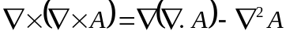. | CO4 | (07)
8. | a) | Give physical interpretation of divergence of a vector. | CO4 | (02)
 | b) | At any point on the curve 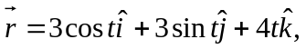find normal vector. | CO4 | (04)
 | c) | Find the directional derivative of 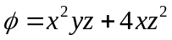 at the point 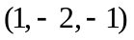 along the vector 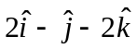. | CO4 | (07)
 | d) | Find the values of and, so that the surfaces 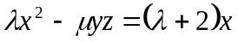and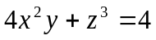 may intersect orthogonally at the point (1,-1, 2). | CO4 | (07)
 |  | UNIT- V
9. | a) | State Stoke’s theorem. | CO5 | (02)
 | b) | Using Green’s theorem evaluate 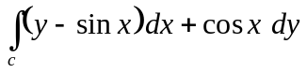, where is the plane triangle enclosed by the lines 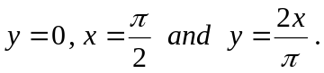 | CO5 | (04)
 | c) | Evaluate 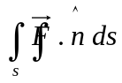 when 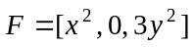 and is portion of the plane  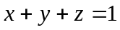in the first octant. | CO5 | (07)
 | d) | Using Stoke’s theorem evaluate 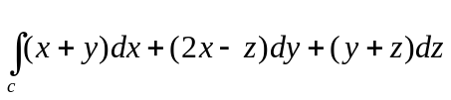 where c is the boundary of the triangle with vertices 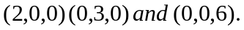 | CO5 | (07)
10. | a) | State Gauss divergence theorem. | CO5 | (02)
 | b) | Evaluate using Stoke’s theorem 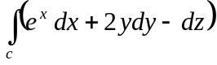, where is the curve 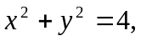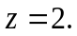 | CO5 | (04)
 | c) | State and prove Green’s theorem in a plane. | CO5 | (07)
 | d) | If 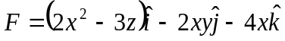, then evaluate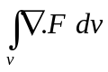 where is the closed region bounded by the plane . | CO5 | (07)

****************

